Half a Rotary year in D2405 has passed. Let’s review how our district and its clubs performed! Below you will find summarized information about donations of our clubs to funds managed by the Rotary Foundation and projects financed by Global Grants and District Grants.

Club donations 1 July - 31 December 2024

Total amount of donations to the Annual Fund – SHARE (AF) was only 2,584.45 USD. Only 16 out of 69 clubs donated. The Top 3 donors are shown on the table.
The goal amount of our donations in 2024-2025 is 50,000 USD or 20 USD per member.
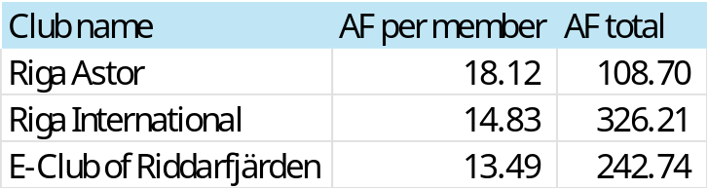
Please plan your donations for the second half of the Rotary year so that we can reach the goal of our district! The best way to donate is to register in My Rotary a recurring donation. Even 5 USD a month from everyone would be enough to reach the goal and support our great Rotary projects and programs!

Total amount of donations to the Polio Plus fund (PPF) were 29,838.92 USD, largely thanks to Kalmar Slott RC – this club donated all its cash, 9,381 USD, to the PPF before being liquidated.
33 out of 69 clubs donated, the Top 3 donors are shown on the table. Thanks a lot to them for their fantastic generosity!

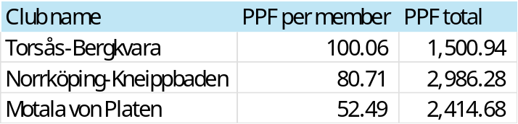
The goal amount of our donations to the PPF in 2024-2025 is 50,000 USD. So far only 8 clubs have exceeded 20 USD per member threshold.
Wars in many regions of the world hinder vaccination of children against polio and the situation is getting worse. The disease spreads and more funds are needed to erase it forever. We must donate and help fight this terrible disease!

Donations to other funds were 1,452.24 USD, most of it (83%) came from Norrköping Louis de Geer RC. In total, only four clubs made such donations.

There were no new donations to the Endowment fund.

Unfortunately, 27 clubs of our district have not donated at all to any funds of the Rotary Foundation. Only our voluntary donations to the Rotary Foundation make an impact on the world outside Rotary. Membership fees what everyone of us pays to Rotary International support only internal RI activities.

Global Grants
Active Global Grants of the district are shown below.
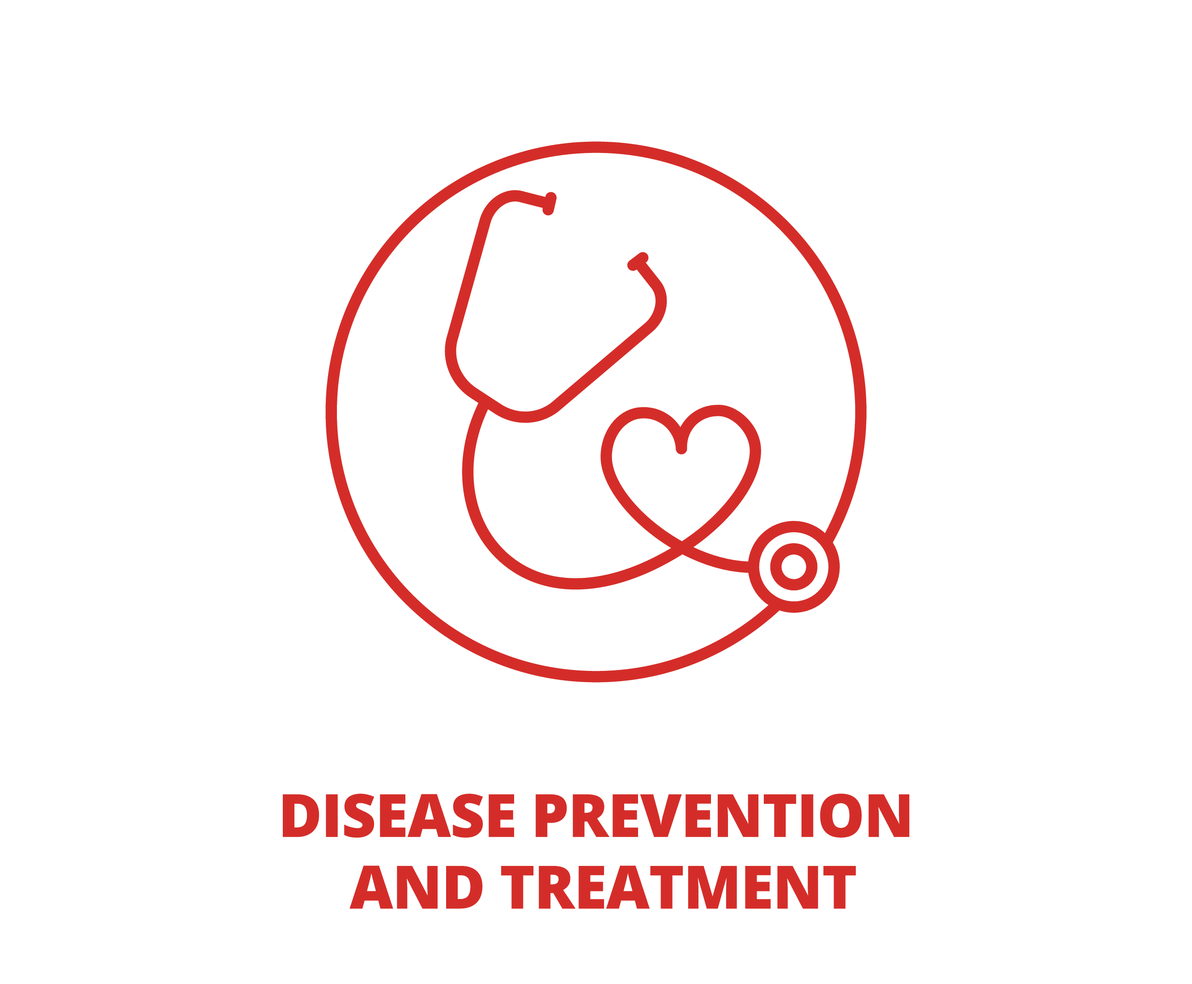
Project description Focus area
GG2351640 | Supply of lifesaving medical equipment to the Kyiv Municipal Emergency Hospital
Host: Kyiv-City RC (Ukraine), int. partner: Strängnäs RC (Sweden)
Funding: 4 clubs and 6 districts (D2370 donated $6.0k, D2410 - $3.7k from DDF)
Total funding $37,000 | Approved 22.09.2023, paid
GG2460156 | Wings of Hope, new workshop development support for disabled people in Sigulda, Latvia
Host: Riga Hansa RC (Latvia)
Int. partner: Münster-Himmelreich RC (Germany)
Funding: 4 clubs and 5 districts (our D2405 donated $7.1k from DDF)
Total funding $72,461 | Approved 24.01.2025, unpaid
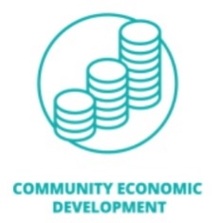

District Grants
In Rotary year 2024-2025 the amount of District Designated Funds (DDF) available for District Grant was $8,994 whereas the amount of grants requested by 10 clubs was $16,373. The Rotary Foundation Committee followed priority rules set in the District Grant Policy and correspondingly approved 7 of project applications, see the summary table below.
Applicant Rotary club | Name of the project | Grant, USD
Värmdö Skärgård | Save the Baltic Sea - Education of “Rotary Baltic Sea Ambassadors” | 1,354
Strängnäs | Stoppa tonårsgraviditeter (Stop teenage pregnancies) | 957
Nyköping | Sörmland camp for girls 2025 | 1,316
Rīga Astor | Art without barriers for young people with special needs | 1,069
Jurmala | Children are inspired by Jurmala! | 1,709
Ventspils | Tango as resistance and cooperation | 1,726
Salaspils | Scholarship Support for talented young people studying at Riga region municipality schools | 863

Your donations to the Annual Fund - SHARE increase the amount of DDF and corresponding grant amounts available to our clubs for their projects. Every SEK or EUR makes a difference! Please donate!

